Sunset Palms Elementary School
School Advisory Council Meeting Minutes
January 10, 2024
Media Center
2:30 p.m.

Members in attendance:

Called to order at 2:34 p.m. (Cathy Peterson, SAC Chairperson)

Approval of Meeting Minutes from December 6, 2023
The Meeting Minutes from December 6, 2023 were reviewed by the membership. Tanya Gutierrez moved to approve the minutes. The motion was seconded by Ms. Marcus. All voting members were in favor. None opposed or abstained. The motion was unanimously approved.

Principal’s Report (Karen Riddle, Principal)
Mrs. Riddle reported that the School Effectiveness Questionnaire (SEQ) was live on the district website and encouraged the membership to respond. PTA Bingo Night will take place on January 26, 2024. Mrs. Riddle shared that before the quarter began, teachers took a planning day to analyze data and tailor lesson plans to assist students in specific areas of need. Mrs. Riddle advised that the Safety Patrol Trip is January 17-19 and that SPE students would be flying for the first time instead of taking the train due to the number of hours spent on the train and the lack of volunteers needed to safely travel by train. Teacher volunteers preferred to fly this year. Finally, Mrs. Riddle reported that SPE has been given an “A” grade by the State of Florida. Pursuant to the Florida Statutes, such a designation requires that SAC vote on the School Recognition Program ballot by February 1, 2024.

Florida School Recognition Program Ballot (Deb Barreiro, A Recognition Committee Chair)
Mrs. Barreiro presented the A recognition ballot, created by the A recognition committee to the SAC and led a discussion regarding the ballot.

. 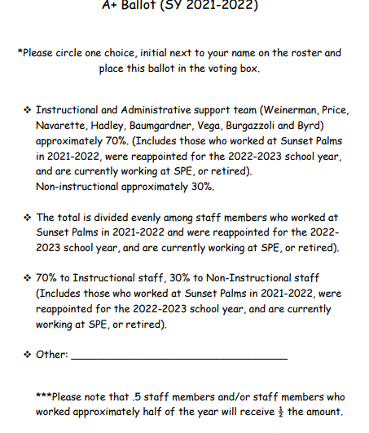

The SAC approved the ballot above with no changes.

Staff voted on the ballot on January 12, 2024. The following option was selected by 80% of the staff voting.

Instructional and Administrative support team (Weinerman, Price, Navarette, Hadley, Baumgardner, Vega, Burgazzoli and Byrd) approximately 70%. (Includes those who worked at Sunset Palms in 2022-2023, were reappointed for the 2023-2024 school year, and are currently working at SPE, or retired). Non-Instructional approximately 30%.

Request for agenda items for next meeting (Cathy Peterson, SAC Chairperson)
It was requested that SPE’s policy/district policy regarding activities be discussed. Mrs. Marin announced that immediately following the next SAC meeting, on February 7, 2024, PTA General Assembly #2 will take place in the Media Center to decide on the SPE PTA Nominating Committee, which will slate the candidates for the SPE PTA 2024-2025 Executive Board.

Next Meeting
Wednesday, February 7, 2024 at 2:30 p.m.

Tanya Gutierrez moved to adjourn. The motion was seconded by Mr. Burgazzoli.

Meeting adjourned at 2:50 p.m.

